**No Code Salesforce app**

<https://trailhead.salesforce.com/content/learn/projects/quickstart-devzone-app?trailmix_creator_id=strailhead&trailmix_slug=build-your-developer-career-on-salesforce>

* Create a custom object

Setup > Object Manager

Allow Reports

Allow Activities

* Create a tab (so we can access it)

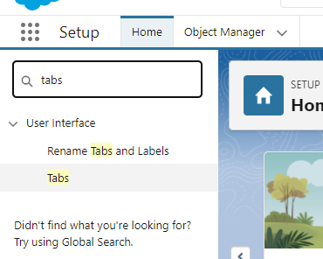

Custom Object Tabs > New

Select the custom object you just created

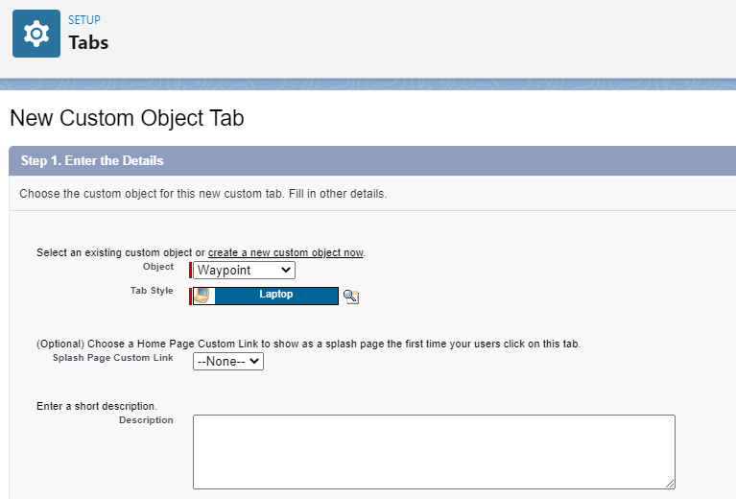

Select where you want this tab to appear. Default is everywhere, but for this example we will deselect everything (we will create an app and add it there)

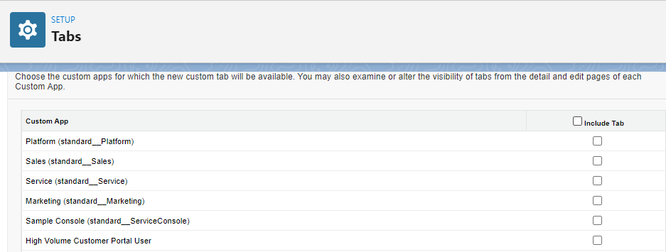

* Create an App

App Manager

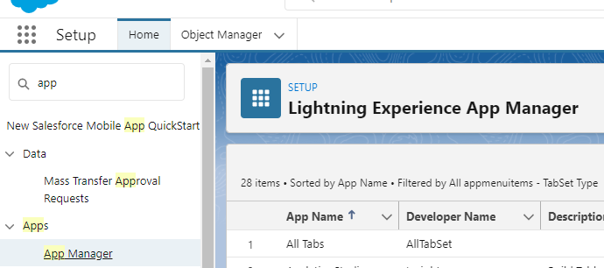

New lightning app

Customize as desired (themes, images, etc…)

If nothing else you will probably need to change the navigation options. Example:

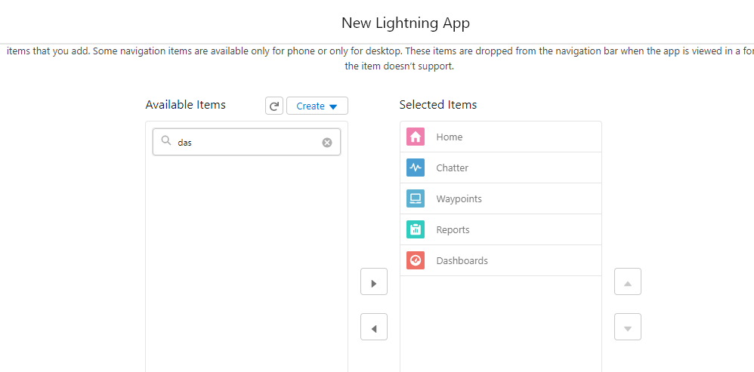

Add user profiles (who will see this?)

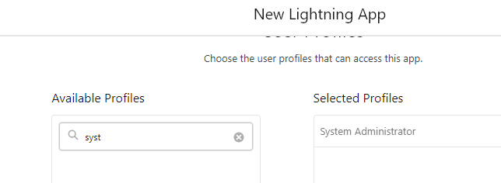

Now you can run it:

Create some new entries

Lots of stuff is automatically created for you

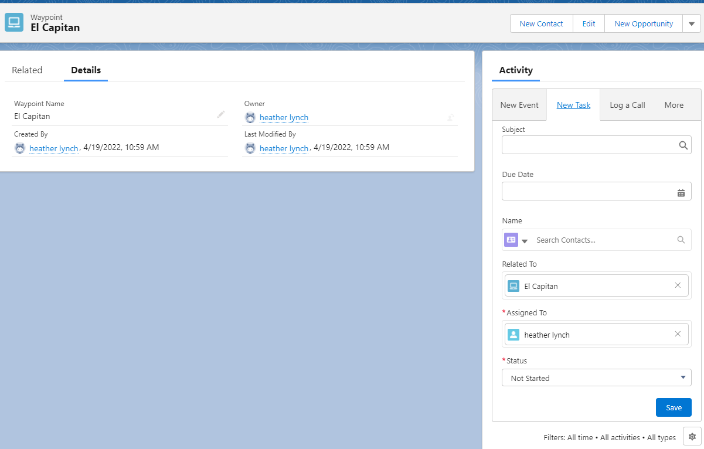

Quick Actions – mainly used in mobile

Setup > Global Actions

New Action

Select the Waypoint object

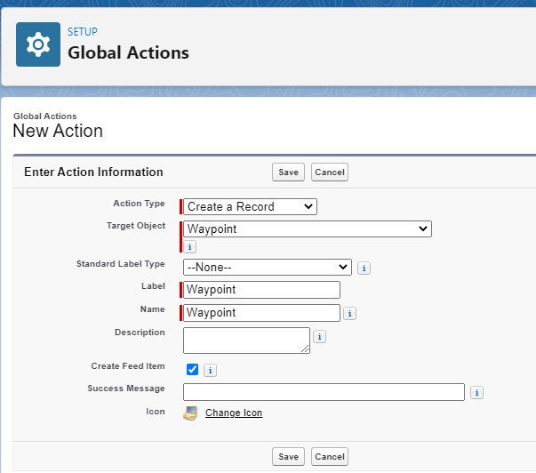

Brings you to the layout screen

You can design the screen as desired

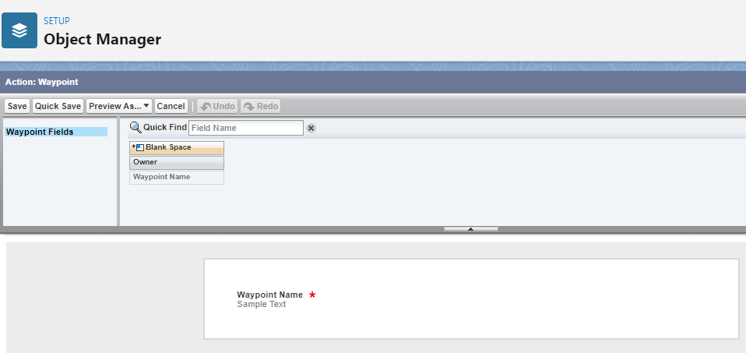

Need to Publish it

Publisher Layouts:

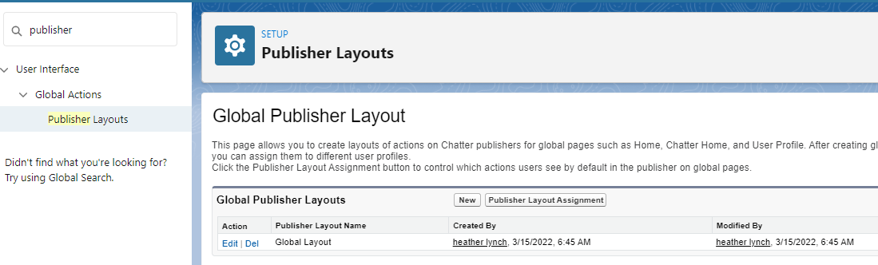

Select Edit next to the Global Layout (default when you create the org)

Remove some stuff by dragging it from below to the upper box

Before:

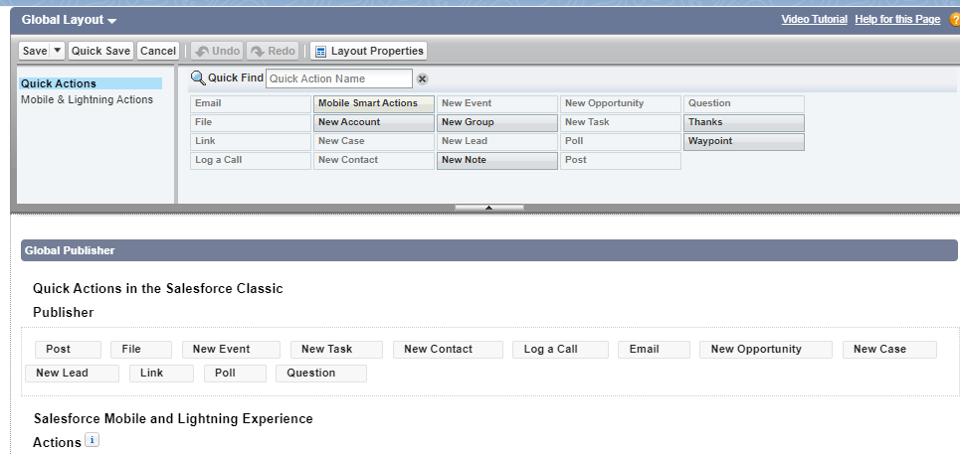

After:

